FOR IMMEDIATE RELEASE
Media Contacts:
Haley Banwart
515-320-5385 | haleybanwart@meyocks.com

Ann Taylor
515-243-7063 | anntaylor@wallace.org

Seasoned Chef Saralyn Smith Joins Wallace Centers of Iowa to Lead Food Programming and Culinary Experiences
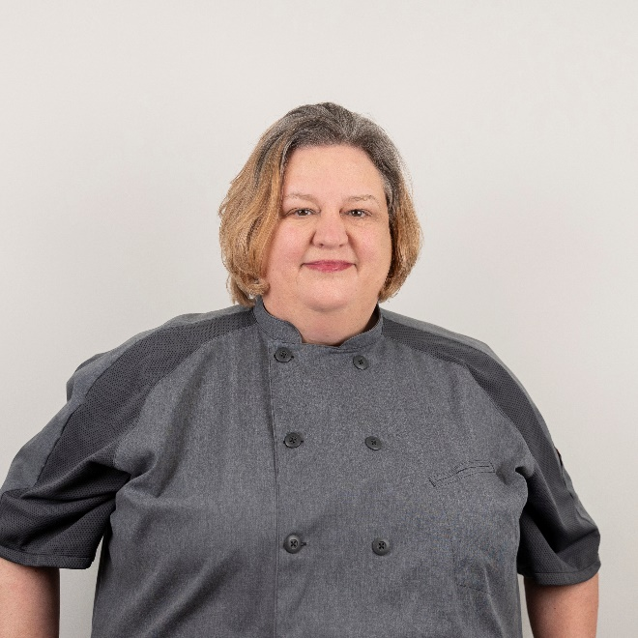
ABOVE: Saralyn Smith, new chef and director of food programming at Wallace Centers of Iowa.

DES MOINES, Iowa (Apr. 16, 2024) — The Wallace Centers of Iowa, a nonprofit that connects food, land and community, hires Saralyn Smith as its chef and director of food programming.

Smith brings over 15 years of culinary experience to her new role and is set to reimagine the organization’s educational food programming and culinary events. She aims to strengthen community ties by emphasizing sustainable food systems and locally sourced ingredients.

“We are excited to have Saralyn join us full-time to lead our food programs at both the Wallace House and the Wallace Farm,” says Debra Houghtaling, president and CEO of Wallace Centers of Iowa. “Having Saralyn onboard will allow us to seamlessly connect our programming efforts across both locations.”

To showcase Smith’s culinary vision and talents, the Wallace Centers of Iowa will be hosting a limited five-course dinner series at the Wallace House on April 30, May 7 and May 14. For details and reservations, visit www.PLACEHOLDER.

Smith was the first Iowa chef to be accepted into the James Beard Foundation Boot Camp for Policy and Change in 2019. She continues to work with other alumni to improve food systems such as emphasizing regenerative and sustainable agriculture.

Previously, Smith served as Kitchen Manager at Convivium Urban Farmstead, teaching community education programs and leading a zero-waste kitchen initiative. Her background also includes experience as a pastry chef at the University of Iowa and The Hotel at the Kirkwood Center.

Additionally, Smith taught professional baking courses to culinary students as an adjunct instructor at Kirkwood Community College. She earned an associate degree in culinary arts from Kirkwood Community College and a bachelor’s degree from the University of Iowa.

The Wallace Centers of Iowa continues the Wallace family’s legacy of agricultural innovation and public service. Programs and events are based at two historic locations: the Wallace Farm in Orient and the Wallace House in Des Moines.

###

About the Wallace Centers of Iowa
The Wallace Centers of Iowa (WCI) is a nonprofit dedicated to preserving the Wallace family legacy of agricultural innovation and public service by connecting food, land and people. WCI operates across two historic sites, the Wallace Farm and the Wallace House, and plays a crucial role in enhancing the quality of life and sustainability in Iowa. To learn more, visit www.wallace.org.

