About Colette Atwood

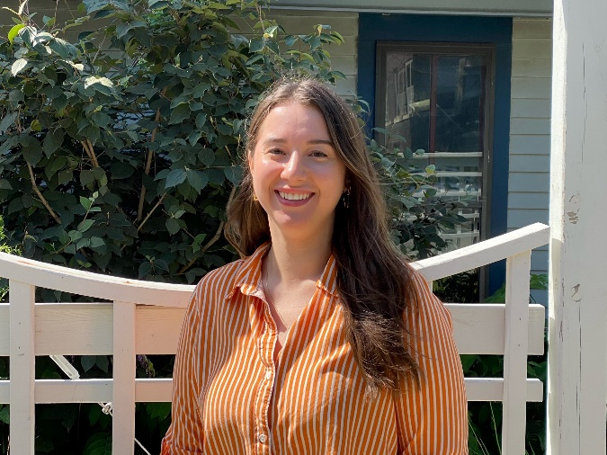
As the Wallace House Site/Operations Manager, Colette welcomes visitors to the historic house and provides critical support for all the educational programs held there including Farm to Table dinners, Hearts and Homes Historic Teas, Know Your Farmer dinners, cooking classes, tours, and special events. Additionally, she oversees the maintenance and grounds keeping and manages a variety of operational functions to keep the entire organization running smoothly.
Colette is a Des Moines native and alum of Grand View University, with a background in education and television. Her passion for local history and historic architecture led her to working at the Wallace Centers of Iowa.

Contact:
Colette Atwood
Wallace House Site/Operations Manager
The Wallace Centers of Iowa

coletteatwood@wallace.org
515.243.7063

