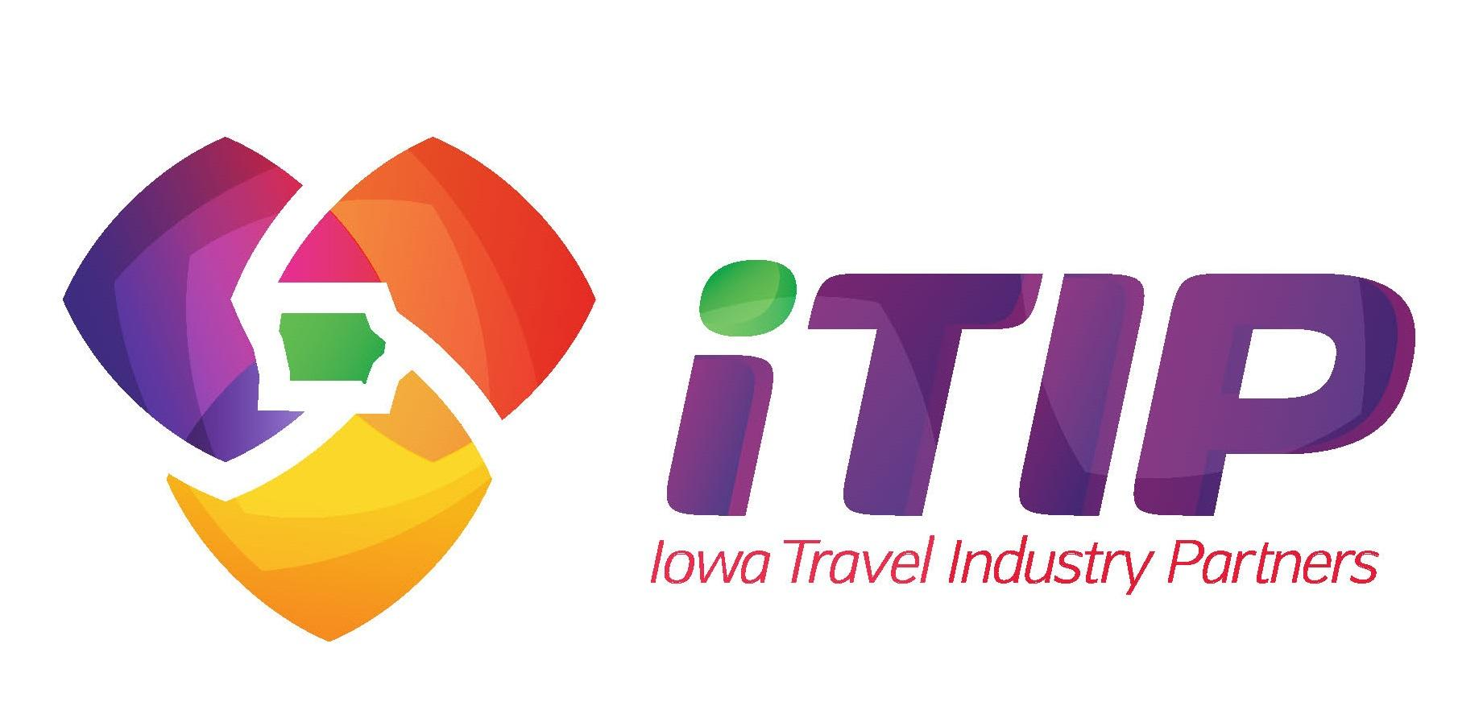

May 15, 2023

FROM: Chelsea Lerud
Executive Director
Iowa Travel Industry Partners

Wallace Centers of Iowa to Receive Statewide Award

DES MOINES (May 15, 2023) – Iowa Travel Industry Partners (iTIP), the leading statewide association of the tourism and hospitality industry, has announced the recipients of the inaugural iTIP Awards. The awards ceremony will take place at the annual meeting on Monday, June 12, 2023, in Cedar Falls.

The Wallace Centers of Iowa is the large market recipient of the Sustainability Initiative Award. This award is reflective of the efforts to reduce the impact of human activity on the environment while promoting tourism in Iowa.

“The Wallace Centers have created destinations for educational programming, locally-sourced meals, provides assistance for food-insecure Iowans, and curated memorable experiences like the Pizza on the Prairie nights,” said Chelsea Lerud, iTIP executive director.

The iTIP Awards are open to all individuals, private businesses, for-profit and non-profit organizations offering a tourism and/or hospitality service in Iowa. Nominations occurred throughout the spring with the iTIP Foundation Board of Trustees scoring the applications. All recipients were nominated by their peers.

The 2023 iTIP Awards recipients:

- Sustainability Initiative, awards efforts that reduce the impact of human activity on the environment while promoting tourism in Iowa.
  - Small Market: The Blue Water Festival, Okoboji
  - Large Market: Wallace Centers of Iowa, Des Moines and Orient

- Arts, Culture & Heritage, recognizes a business, organization, event, or destination that showcases the arts, culture, or history for the enhancement of the tourism experience and economic well-being of the community.
  - Small Market: American Gothic House, Eldon
  - Large Market: Iowa City Downtown District, Iowa City

- Only in Iowa, presented by CTM Media, recognizes a business, organization, or destination that makes the state of Iowa unique, noteworthy, and proud.
  - Madison County and the Field of Dreams Movie Site, Dyersville (tie)

- Rising Star, presented by Neapolitan Labs, is an award recognizing someone new to the Iowa tourism industry within the past five years who has demonstrated leadership, commitment, and passion for the Iowa travel industry.
  - Small Market: Andy Kelleher, Lansing Main Street
  - Large Market: Emma Schwaller, Council Bluffs CVB

- Service Excellence, presented by Oak View Group, recognizes a business or organization that has achieved significant success and growth by providing exceptional customer service.
  - Small Market: SOMM Wines, Fairfield
  - Medium Market: King’s Pointe Resort and the City of Storm Lake
  - Large Market: Catch Des Moines

- Legislator of the Year, presented by the Iowa Gaming Association, is presented to a member of the Iowa Senate or Iowa House of Representatives who actively supports legislation that bolsters the economic impact that tourism produces for the state.
  - Carrie Koelker, Senate District 33 (Dyersville)

- iTIP Partner of the Year, presented by de Novo Marketing, is awarded to business, organization, or individual that has provided extraordinary support to iTIP in the past year:
  - Nick Pfeiffer, Think Iowa City

- The Abby Kisling Leadership Award, presented by the Council Bluffs CVB, is named in honor of the late Abby Kisling, longtime member of Iowa's tourism industry. Kisling worked for Tipton Economic Development, Eastern Iowa Tourism Association, Greater Ottumwa Convention & Visitors Bureau, and the Villages of Van Buren. Her leadership for small and rural Iowa communities provided them a strong voice within the industry. She brought spunk and spirit to everything she did.
  - Ginger Williams, Charles City Chamber & Tourism

- The Joe Taylor Vision Award, presented by Visit Quad Cities, is named in honor of the late Joe Taylor, longtime CEO of Visit Quad Cities and industry visionary. Taylor worked for the region’s official destination marketing and management organization for almost 30 years. He served as executive director of the Davenport Area Convention & Visitors Bureau in 1989. Then on July 1, 1990, the three local tourism organizations officially merged to become the Quad Cities Convention & Visitors Bureau, now Visit Quad Cities.
  - Carla Eysink, Marion County Development Commission, Pella

The recipients and their guests are invited to a reception and award ceremony at 4:00 pm on Monday, June 12 at the Bien VenU Conference Center in Cedar Falls. The event is emceed by Saturday Night Live alum and Iowa native, Gary Kroeger. Preceding the awards is the iTIP annual meeting, featuring keynote speaker Sydney Rieckhoff, CEO of Iowa-based Almost Famous Popcorn Company. Details of the annual meeting and awards program can be found at IowaTravelIndustry.org.

-end-

